心智繪圖
http://blog.udn.com/article/article_print.jsp?uid=ruru1211&f_ART_ID=1241379
http://msps-tw.blogspot.com/2015/09/1-3_23.html

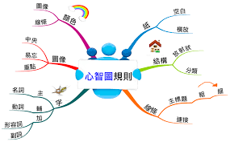
*心智圖教作文https://www.youtube.com/watch?v=tsbEUDyFjh4

*繪製心智圖的方法http://www.bele123.com/%E6%96%87%E7%AB%A0%E5%B0%88%E6%AC%84/%E3%80%90%E5%84%AA%E9%9B%85%E4%BA%BA%E7%94%9F%E3%80%91%E7%B9%AA%E8%A3%BD%E5%BF%83%E6%99%BA%E5%9C%96%E7%9A%84%E5%85%AD%E6%AD%A5%E9%A9%9F

